Ideation Phase

Brain Storming & Idea Prioritization

**Project Name :** Plasma Donor Application

**Team ID:** PNT2022TMID02871

**Step-1: Team Gathering, Collaboration and Select the Problem Statement**

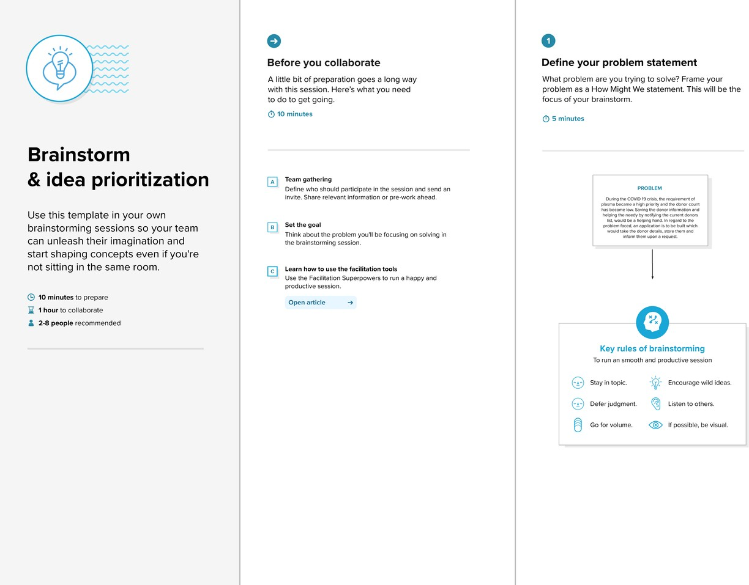

Step-2: Brainstorm and Idea Listing

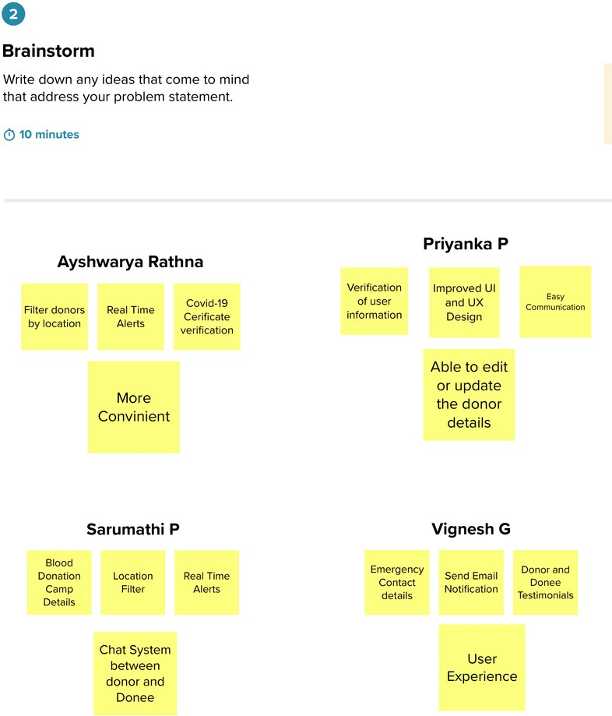

Ashrutha

Anu Gayathri

Abinaya

Anjali Niranjana

Step-3: Grouping

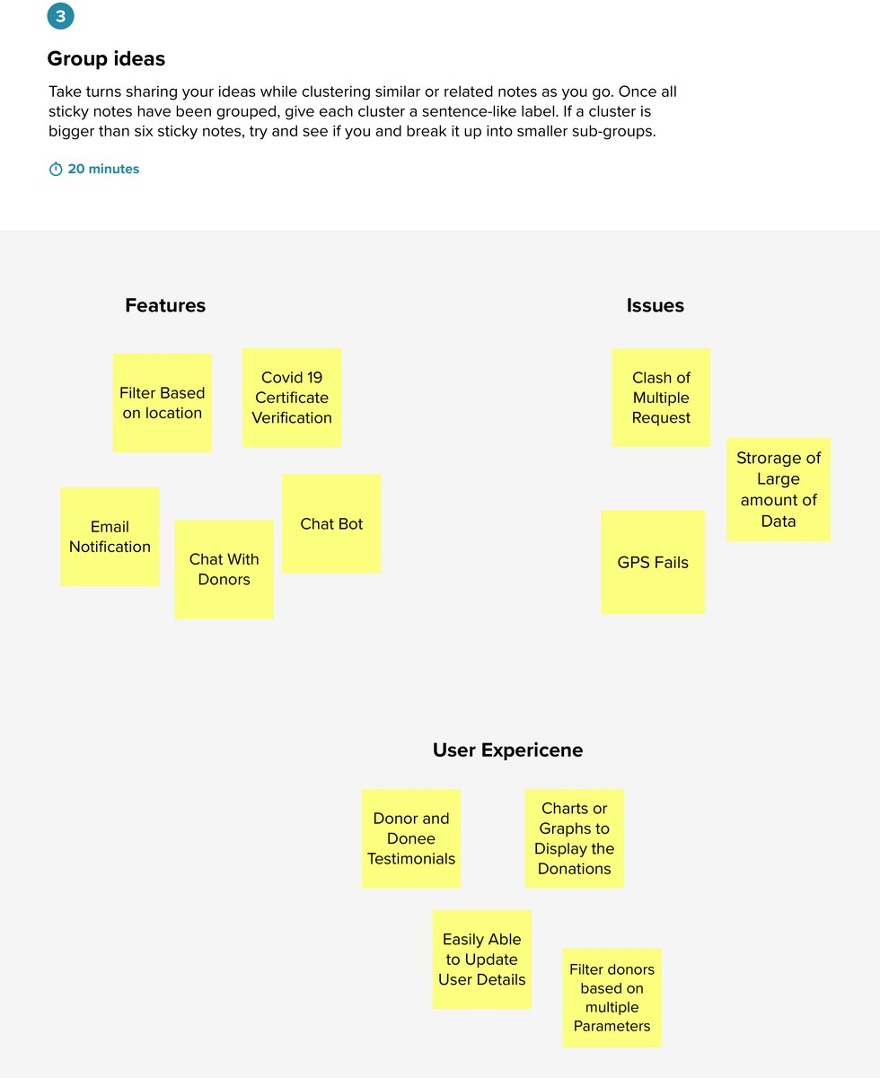

Step-4: Idea Prioritization

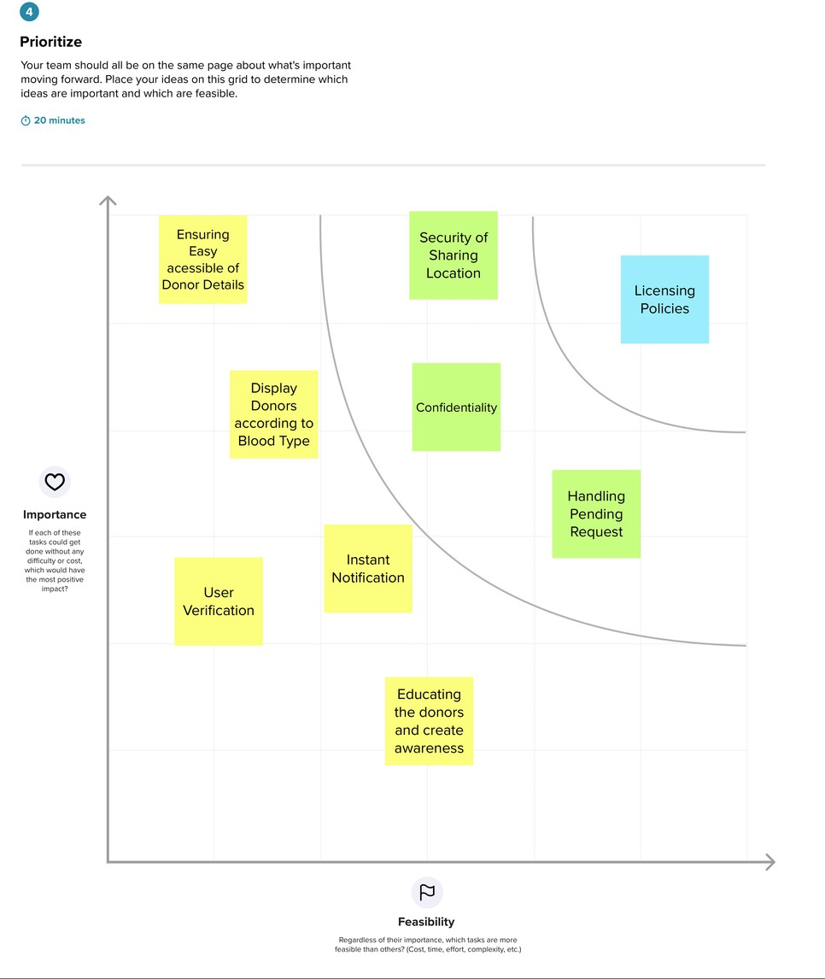

Step-5: Top Ideas

